**2. FINANCE SECTION**

* **Question**

Yara Inc is listed on the NYSE with a stock price of $40 - the company is not known to pay dividends. We need to price a call option with a strike of $45 maturing in 4 months. The continuously-compounded risk-free rate is 3%/year, the mean return on the stock is 7%/year, and the standard deviation of the stock return is 40%/year. What is the Black-Scholes call price?

**Solution**

Given the Black Scholes Formula

The Black Scholes Theory applies to the European stock option but a non-paying dividends Americans stock (NYSE) can use Black Scholes option for call and put prices

For a Black Scholes Call Price



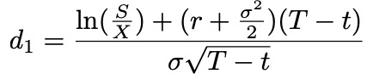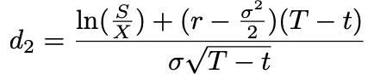

d1=

d1=

d1=

d1=

d1=

d1=

d1=

d1= 7.5075*(-0.6106)

d1 = -0.4584

d2 = d1-ℴT

d2 = -0.4584- 0.40.333

d2= -0.4584-(0.4*0.577)

d2= -0.4584-0.2308

d2= -0.6892

Two decimal places

d1 = -0.46 N1= 0.03228

d2= -0.69 N2= 0.245

Cp = N(d1) St – N(d2) ke-r(t)

Cp = (40) (0.3298)- (0.2451) ($\frac{45}{e o.o3*0.33}$)

Cp = 12.912- 14.561

Cp = 12.912- 10.921`

Cp = $1.991